GIT

**Def**

It is a Global Information Tracker

It is a Distributed version control system (or) Source code management We are controlling the versions of the applications through GIT

Every application contains code. That code was maintained by SCM

 Git is used to track the files

 It will maintain the multiple versions of the same file

 Git is a platform independent i.e.., it will open in all systems  It is a free and open Source

 Git save time and developers can fetch and create pull requests without switching  It is 3rd generation of VCS

##### VCS History

1. SCM(Source code control management) - To track only one file
2. RCS(Revision control system) - Track multiple files but not directories
3. CVS(concurrent version system) - Track multiple files and directories but single user
4. SVN(sub version) - Track multiple files & directories and multiple users
5. GIT(Updated)- Distributed version control system

##### Stages in GIT

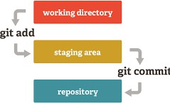

Working Directory :

Untracked files are present here. When a new file is created, updated or an existing file deleted, those changes automatically go into the working area.

Staging Area:

Here, changed files are present here. So, we can commit/save Repository:

 A Repository has all the project - related data

 Repository in git is considered as your project folder

 It contains the collection of the files and also history of changes made to those files

**Types Of Repo:**

Local Repo:

The local repository is everything in your git directory. Mainly what you will in your local repository are all of your checkpoints (or) commits. It is the area that saves everything (so don’t delete it)

Remote Repo:

The remote repository is a git repository that is stored on some remote computer. It allows you to centralize the work done by each developer

Central Repo:

This will be present in our GitHub

##### Git workflow

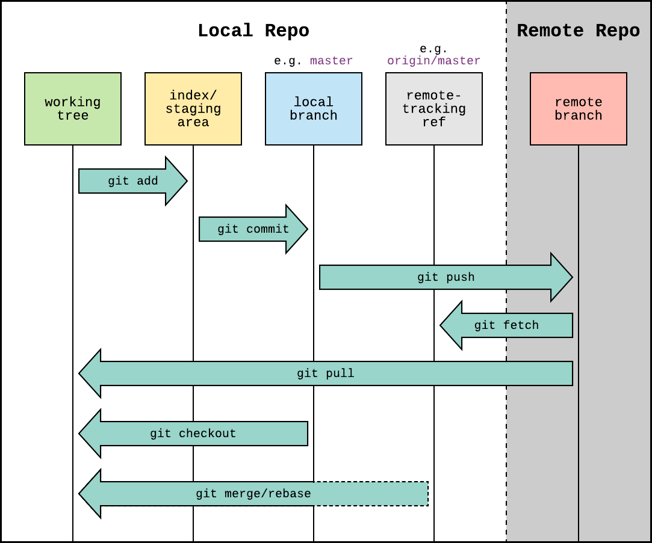

GIT Installation in Linux

sudo yum install git -y ⟶ from ec2-user yum install git -y ⟶ from root user

git --version ⟶ check the git installed or not in your local

We have to initialize the empty repository. Otherwise, file will not track/commit git init . ( . represents current directory)

GIT ADD (Track the files)

 Git add command is straight forward command. It add files to the staging area  We can add single or multiple files at once in the staging area

 Every time we add or update any file in our project, it is required to forward updates to the staging area

The staging and committing are co-related to each other

git add filename

git add * (all files) git add -f * (Forcefully)

git add . (hidden & normal files)

Untrack the files

git rm --cached filename git rm --cached *

git rm -r --cached . (for all files) GIT STATUS

 The git status command is used to display the state of the repository and staging area  It allows us to see the tracked, untracked files and changes

 This command will not show any commit records or information GIT COMMIT

 It is used to record the changes in the repository  It is the next command after the git add

 Every commit contains the index data and the commit message git commit -m “enter the commit message” filename

git commit -m “enter the commit message” . ( . represents every changed/ tracking files)

At a time track the file and save the file in repository git commit -a -m “enter the commit message” filename

See the list of commits history in git git log

git log --oneline

If you want see the commit file name git show commitID --name-only

If I want to see how many times i’m committed the file ? git log --follow --all fileName

Note:- We can’t commit the committed file. We can commit if that file has any changes

#### GIT Configure

If you want to give your username and E-mail id to those commits then git config --global user.name “EnterYourName”

git config --global user.email “EnterYourEmailId”

--global :- If we give global means that particular commit name or email id applies to all the git repository. If we don’t give global also it works but it will work on that particular/current repository

Note: now giving the git log command to see changes, it won’t work because after configuring we haven’t done anything. Now create a file and commit that file and give git log you will see changes as you configure.

#### GIT Ignore

 It will be useful when you don’t want to track some specific files then we use a file called .gitignore  create some text files and creates a directories with “jpg” files

 vi .gitignore  *.txt

 Now all the text files will be ignore

 If you really again want that file use: git add -f *

Note: If you want to ignore a file, before tracking only you have to be put. Otherwise, it will be no use

###### Changing the details for Latest commit

git commit --amend --author “sandy<[sandy@gmail.com](mailto:sandy@gmail.com)>”

After performing this command, one file opened, don’t do anything. perform ‘wq’ .

--amend : It’s a flag, if you want to edit the commit details use this command

--author : Author details edited

If you want to edit the message details for commit

git commit --amend -m “EnterTheEditingMessage” filename

###### How to add a file to previous commit ?

git commit --amend --no-edit fileName

### Deleting commits

##### Reset

To remove local commits let's use “reset” command Reset commands uses three different options

1. --mixed : This is the default option(remove commit and move changes to working area)
2. --soft : If we give soft means files not deleted only commit is deleted
3. --hard : It removes commits and permanently discarded changes without our permission git reset --hard HEAD~1 → This is deleting the latest commit

git log ⟶ Head will moved to latest commit

git reset --hard HEAD~3 ⟶ It will delete latest i.e., top 3 commits Delete all commits ⟶ git update-ref -d HEAD

Note:- If we perform above command we don’t have any commits but inside files data is deleted

##### Revert

If you want to undo local/remote commit use this

It will not remove the commit but it removes changes in the commit and makes a new commit Revert used to delete specific/particular commit

git revert commitID

##### reset vs revert

 Reset removes commit from the history and revert will not

 Reset works for local commits and revert works for local and revert commits

# Branches

A branch represents an independent line of development

The git branch command lets you create, list, rename, and delete branches The default branch name in Git is master

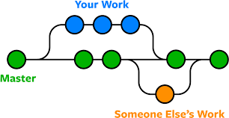

Note:- If you perform git branch first time, you can’t see any branch including master also. You can see when you commit something first time to repo. Otherwise, master is not visible

To Creating a new branch ⟶ git branch branch_name To see current branch ⟶ git branch

To switch branches ⟶ git checkout branch

To create and switch branch at a time ⟶ git checkout -b branch_name

To rename a branch ⟶ git branch -m old_name new_name

To delete a branch ⟶ git branch -d branch_name

To Rename the current branch ⟶ git branch -M newBranchName

The -d option will delete the branch only if it has already been pushed and merged with the remote branch.

To delete a branch forcefully ⟶ git branch -D branch_name

Use -D instead if you want to force the branch to be deleted, even if it hasn’t been pushed or merged yet. The branch is now deleted locally

Note:- If you create one file inside a branch from master. It will be present in all branches & master. But, whenever you are committing the file into a particular branch. It will not present

#### Feature Branch

 They are short lived branches.

 We can simply called ephemeral i.e. short lived objects  we delete it after it is integrated to develop

### Merging

Getting the all commits from one branch to another branch. means getting files and commits from one branch to other

Note:- First, which branch you need to merge, go inside that branch and perform that merging Eg: so, I’m going to master i.e.., git checkout master then you can do merge

git merge branch_name Cancelling the merge ⟶ git merge --abort

#### GIT rebase

If you have 5 commits in master branch and only 1 commit in devops branch, to get all the commits from master branch to devops branch we can use rebase in git.

git rebase branch_name

#### cherry-ick

Cherry pick picks specific/particular commits from another branch and merges with the current branch

We can pick through commitID

Eg:- If you have 5 commits in master branch and only 1 commit in devops branch, to get specific commit from master branch to devops branch. we can use cherry pick

git cherry-pick commitID

##### merge conflicts

GIT makes merging super easy

CONFLICTS generally arise when two people have changed the same lines in a file (or) if one developer deleted a file while another developer is working on the same file

In this situation git cannot determine what is correct!

Let’s understand in a simple way!

cat > file : hi all ⟶ add & commit ⟶ git checkout -b branch1 cat > file : 0987654 ⟶ add & commit ⟶ git checkout master cat >> file : sandeep Chikkala ⟶ add & commit

Now perform , git merge branch1

 We have to do manually to resolve our conflicts

##### How to Resolve merge conflicts ?

open file in VIM Editor and delete all the conflict dividers and save it! add git to that file and commit it with the command

### stash

Using the git stash command, developers can temporarily save changes made in the working directory.

It allows them to quickly switch contexts when they are not quite ready to commit changes And it allows them to more easily switch between branches

It saves changes in working and index areas and saves it to a different location and making a way for other important tasks

It can be access only inside the branch

Generally, the stash’s meaning is “store something safely in a hidden place”

Apply the stash ⟶ git stash (or) git stash apply Remove the stash ⟶ git stash clear

Check the stashes ⟶ git stash list Remove the last stash ⟶ git stash pop

Remove particular stash ⟶ git stash drop stashID eg:(git stash drop stash@{0})

### merge vs rebase

 When there are changes on the main branch that you want to incorporate into your branch, you can either merge the changes in or rebase your branch from a different point

 Merge takes the changes from one branch and merges them into another branch in one merge commit

 Rebase adjusts the point at which a branch actually branched off (i.e., moves the branch to a new starting point from the base branch)

 Generally you’ll use rebase when there are changes are made in main/master branch that you want to include in your branch.

 You’ll use merge when there are changes in a branch that you want to put back into main  to merge : git merge branch_name

 to rebase: git rebase branch_name

If I delete/modify the branch in local, I want to see the changes in server ⟶ git fetch -p

github

 It is a web-based platform used for version control

 It simplifies the process of working with other people and makes it easy to collaborate on projects  Team members can work on files and easily merge their changes in with the master branch of the

project

 In github, default branch is ‘main’ branch

 If you want to push code from local to central we use github

Readme file: It is a text file, it tells about the particular repository what is the version and what actually the code does, how to use/see the repo, all information developers are write inside a readme

Blame: This command presents the developer details at each and every line

##### Commands

Linking the repo from local to central ⟶ git remote add origin url

push the code from local to central ⟶ git push -u origin branch_name Note: without commit you can’t push the file

Remove the repository ⟶ git remote rm origin push multiple branches at a time ⟶ git push -u origin --all

Delete github branch from local ⟶ git push -u origin --delete github_branch_name See all branches (local & central) ⟶ git branch -a

see the repo whether it’s linked to local/not ⟶ git remote -v

see the logs of remote repo ⟶ git log origin/branch_name

#### git pull

 From local to central we have to send our code use git pull  git pull origin branch_name

 git pull

 git pull = git fetch + git merge

 git fetch origin branch_name

 git merge origin/branch_name

 fetch : Inside the central whether we have the changes/not. we will know through by git fetch (or)

It will download remote commits to local but it will not merge (or)

You can review remote changes before you merge

##### Pull Request:

 It is nothing but a merging in GitHub

 Using this pull request we can also resolve github merge-conflicts  select 2 branches and compare and do merge

 base branch - less files will present in that branch

 compare branch - more files will present in that branch

##### Git Cloning:

 git clone is used to get the code from the github

 To clone a git repo we need to have a repository and also check our pwd  git clone repo_url

 now we just cloned the files in repo-A to repo-B

 But before cloning we need to add and commit our files

##### Git Fork:

A fork is a rough copy of a repository. Forking a repository allows you to freely test and debug with changes without affecting the original project

(or)

Fork is used to get the other repositories to our account

## Git Branch Protection rules

Using this feature

1. We can lock a release branch when we stop supporting this release
2. You can create branch protection rule to merge changes to main through PR

##### Advantages:

 Speed

 Simplicity

 Fully Distributed

 Excellent support for parallel development, support for hundreds of parallel branches  Integrity

##### DisAdvantages:

 windows support issue

 Entire download of the project history may be impractical and consume more disk space if the project has long history

Comparison

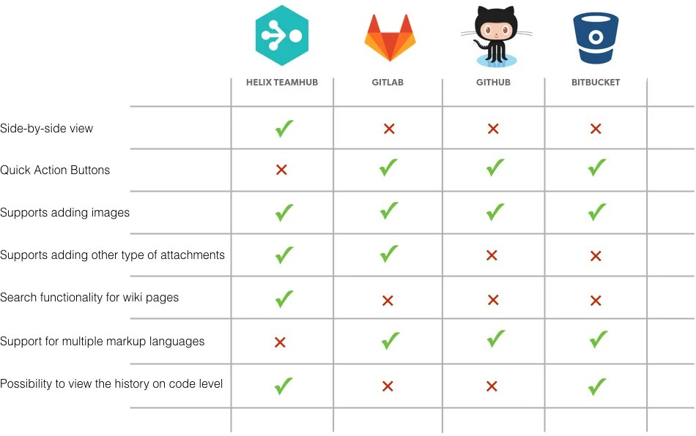

# branching strategy

Branching Strategy is differ from team to teams

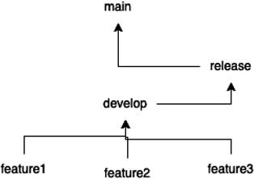

 main ⟶ This is the final branch, this branch should contain clean and bug free code. that’s why do not directly push changes to main

 feature ⟶ This branch should be used for adding new features

 develop ⟶ This branch is used for integrating features and after integrating features we will test it. If there are any bugs occur fix in this branch before merging to main

So, every sprint we need to do release. For managing releases we’re suggested to have release branch. So, release means the changes made by our development to production team

So, from feature we integrate to develop feature is created from develop, and then after integrate back to develop

Once you have features reads i.e, develop branch is ready. we create a release branch

 release ⟶ This branch used for managing release. This branch contains commits (or) features specific to that release. And we merge this release back to main

 So, every time you have release you must create release branch like release 1, 2, 3, ......

 hotfix ⟶ we use this branch for fixing production defects. And this is created from release and make sure this fix is included into the next release. that should be taken by DevOps people

eg: we are having defects in release 1 and we fix those defects using this hotfix branch This is one of the common flows used in real-time

##### Trunk-Based Strategy

Trunk means main branch

we will not have so many branches in this approach we will just have like features

we directly merge changed to main to features

It won’t help in bigger teams. It is helpful only for less team i.e. 1 or 2 developers

## Follow good naming conventions

Naming conventions will help and it is easily communicate with people without explaining them what exactly you are doing

Recommended branch name conventions  feature/sandy/APPS-4727

Naming convention for release branch

* 1. release-0.0.1 (Major.Minor.Patch) (semantic versioning)
  2. release-0.0.2
  3. release-0.1.0

Patch: There is a bug, if you want to fix it that is called patch release Eg: tier puncture patches etc.., Minor: Adding 3 (or) 5 features

Major: A framework change means

## Git Hooks/Scripts

We can execute custom scripts (or) specific operations

for eg: we wanna have a JIRA id in a every commit message Advantage:

When you go with this approach, we know very sure what is the commit, which task the commit is made

If you go to JIRA It should all commits made particular tasks There are server side and client side hooks. Git supports both

When you perform operations on server side, server side hooks comes into the picture